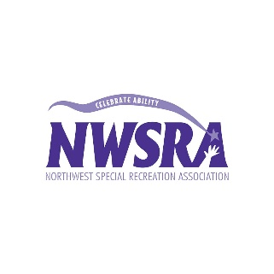
- Big Mac, McDonalds, $3.99
- Nacho Fries, Taco Bell, $1.39
- Crazy bread, Little Caesars, $2.29
- Ihop, pancakes, $5.69
- Chipotle, burrito bowl, $6.50-$8.50
- Raising Canes, box combo, $6.98
- McDonalds, Egg McMuffin, $2.79
- Popeyes, Biscuits, 3.99
- Auntie Anne’s, Original Pretzel, $3.29
- Panda Express, Orange Chicken and Noodles, $5.80
- Portillo’s, Hot Dog, $3.29
- Wendy’s, Chocolate Frosty, $1.99
- Subway, BLT Foot Long, $7.75
- Pizza Hut, Medium Peperoni Pizza, $11.19
- Burger King, Whopper, $4.19
- Dairy Queen, Dilly Bar $1.49
- Wendy’s, Baconator, $6.09
- Portillo’s, Chopped Salad, $8.59
- Buffalo Wild Wing’s, 10 wing combo meal, $9.99
- Sonic, Cherry Slushie, $1.19
- Starbuck’s, Cake Pop, $1.95
- Chick-filet, Chicken Sandwich meal, $5.95
- Panera, Tomato Soup in Bread Bowl, $5.49
- Arby’s, Roast Beef Sandwich, $3.99
- Dunkin Doughnuts, Strawberry Sprinkled Doughnut, $0.99
- Oberweis Dairy, Chocolate Milkshake, $6.19

