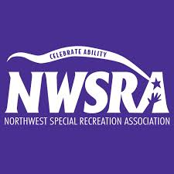
YARN WRAPPED CARDBOARD LETTERS
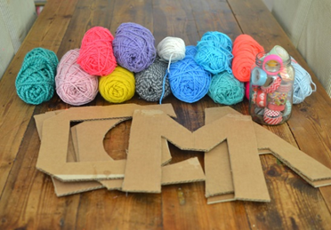
Supplies:
- Cardboard (Large enough to cut out the letter and size you want)
- Sharp scissors
- Yarn (enough to cover the whole letter and as many colors as you want)
- Masking tape
- A plate (optional)
- Pencil
Directions:
- Draw the letter you want to create with your pencil on a piece of cardboard. Draw it as a bubble letter so its large enough to wrap yarn around.

- Cut the letter out with sharp scissors.

- Take your yarn and cut out about 3 feet of yarn multiple times using whatever colors you want.

- Starting on the back of the letter, tape the end of the yarn at the top and start wrapping around the letter

- Once the 3 feet piece of yarn is fully wrapped, secure it with a piece of tape.

- Then you can start with another 3 foot piece of yarn the same color or a different color. Tape the tip of the yarn next to where you left off with the last piece of yarn and continue wrapping.

- Follow these steps until the whole letter is fully wrapped.

- And you’re DONE!
