[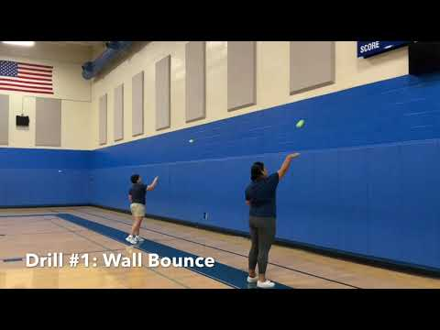](https://www.youtube.com/watch?v=In2CFpRiVgg)Special Olympics Softball Drills

[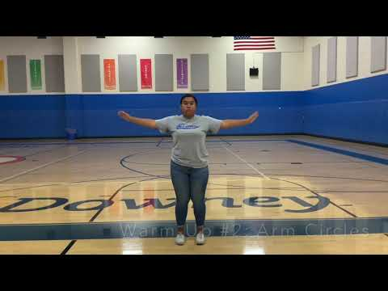](https://www.youtube.com/watch?v=r9mIoP8RB0g)